Process to Follow:
- Framing
- High Level Desing
- Data
- Model+ Training
- Validation
- Deployment
- Monitoring

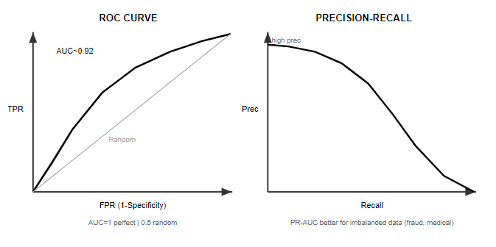
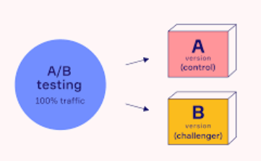
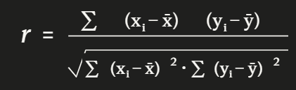
Binary Cross entropy loss function: $L=-\left(ylog⁡(p)+(1-y)log⁡(1-p)\right)$
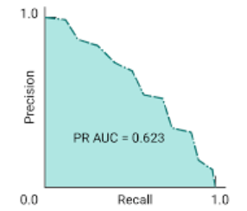

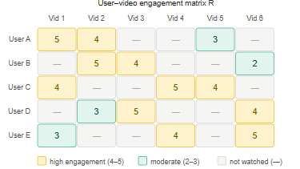
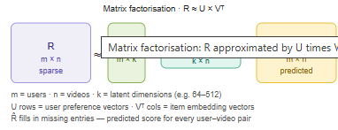
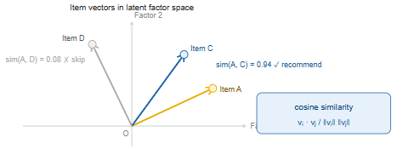
$$cos⁡(θ)=\frac{A⋅B}{∥A∥∥B∥}$$
